Name: Vaibhava Sree
Roll No: 2520030398
3.
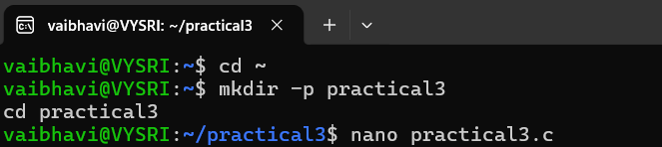
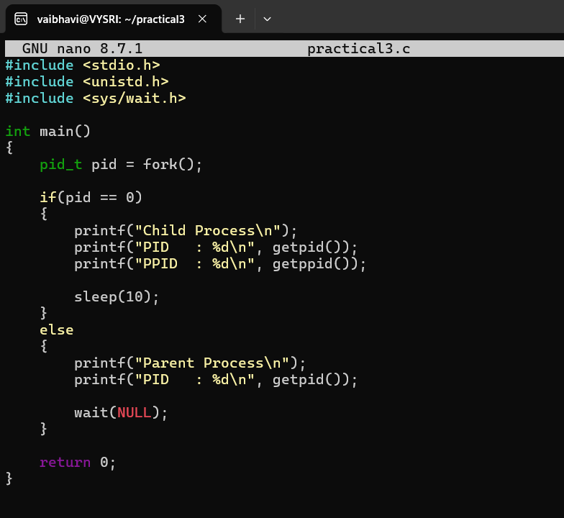
OUTPUT:
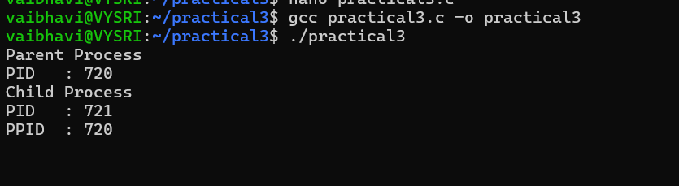
4.
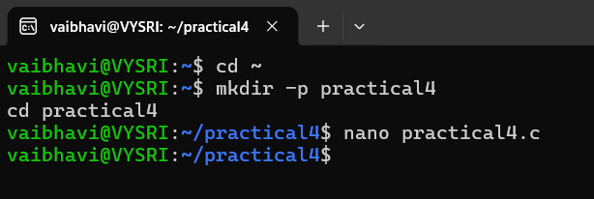
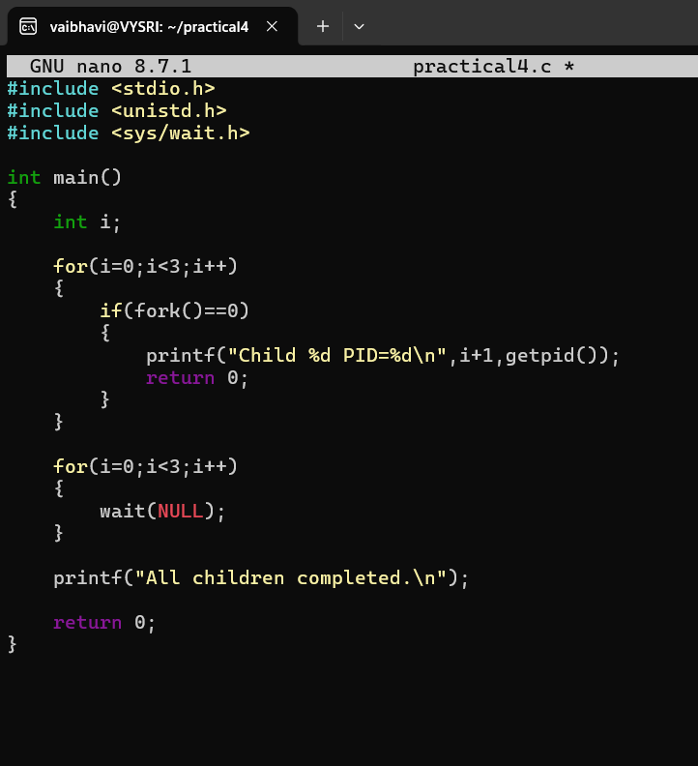
OUTPUT:
